Network analysis and recommendations

Case Study- TV Skyline Omada Network Design

  - Unit Code : MN625
  - Unit Title : Software Managed Network
  - Thushar Thymagondlu Anjanappa MIT232995

Table of Contents
1. Summary of each individual Case Study Reports 3
2. Network Design 4
Additional Technical Implementation Figures 5
a. Gain Visibility and Control by End Users (Human Factor Considerations) 11
b. Realize Strategic Solutions of Designed Network 11
c. Future Trends in Networking 12
3. Innovative Ideas 13
a. Network Performance Improvement 13
b. Network Architecture Selection Rationale 13
References 14

List of Figure
Figure 1: Tailored Network Topology for TV Skyline Mobile Broadcasting 4
Figure 2: shows core router running configuration 5
Figure 3: shows IPv4 interface brief 5
Figure 4:Interface of ipv6 6
Figure 5 : Ipv4 routing table 6
Figure 6 : IPv6 routing tableOSPf of router 7
Figure 7: OSPF configuration of router 7
Figure 8: DHCP configuration of router 7
Figure 9 : Running configuration of Multilayer switch 8
Figure 10: shows VLAN configuration of Multilayer switch : 8
Figure 11 : Trunking configuration of access switch for vlan 10 9
Figure 12 : access switch vlan configuration 9
Figure 13 : DHCP allocation on Vlan 10 10
Figure 14: Ping test within network VLAN 10 10
Figure 15: Ping test with other device on different vlan(30) 10

Summary of Case Study Reports
TV Skyline Mobile Broadcasting
TV Skyline, one of Germany's leading mobile broadcasting companies, launched the Ü8 UHD OB van with 30 high-performance workstations capable of supporting 4K Ultra HD broadcasting. The network infrastructure requirements are scalability, robust security, and high capacity to handle broadcast-grade video transport with low latency and high availability. The optimum solution is a three-level hierarchical structure upon TP-Link's Omada SDN platform with Layer 3 switches (SG6428X) which provide core routing features, various Layer 2 switches (SG3452P, SG3428MP, SG3210) for interfacing the workstations, and widespread VLAN segregation for department separation of traffic.
The combined case studies illustrate the assignment of IP addressing according to an MIT student ID plan (23.35.22.0/24) using a /27 subnet mask to offer 30(n=5, 2^n-2=2^5-2=30) spare hosts per department. Redundant interconnecting links are made available throughout the switches and routers, with LACP trunking being used for load balancing as well as for fault tolerance. Three expert routers are included in the design: a Core Router for intra-VLAN routing, a Broadcast Router for management of multicast traffic, and an Internet Router for secure internet access [10]. Centralized management with the Omada SDN controller provides easy configuration, monitoring, and troubleshooting essential features for a mobile broadcasting deployment where simplicity of deployment and reliability are paramount.

2. Network Design
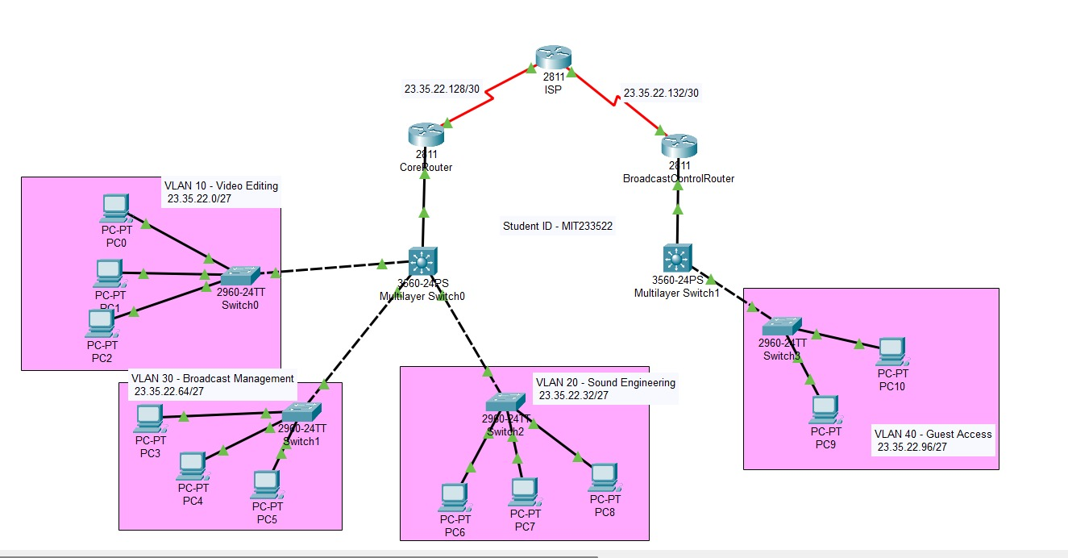
Figure 1: Tailored Network Topology for TV Skyline Mobile Broadcasting
The network diagram outlines a network plan created to meet the mobile requirements of TV Skyline. The design includes a Layer 3 switch for handling VLAN connectivity and access switches that support 30 broadcasting devices through PoE. Four VLANs divide broadcast functions to make sure there is no traffic mix-up and better performance during 4K Ultra HD production.
Router configuration Details:
Core Router Configuration with Network Services:
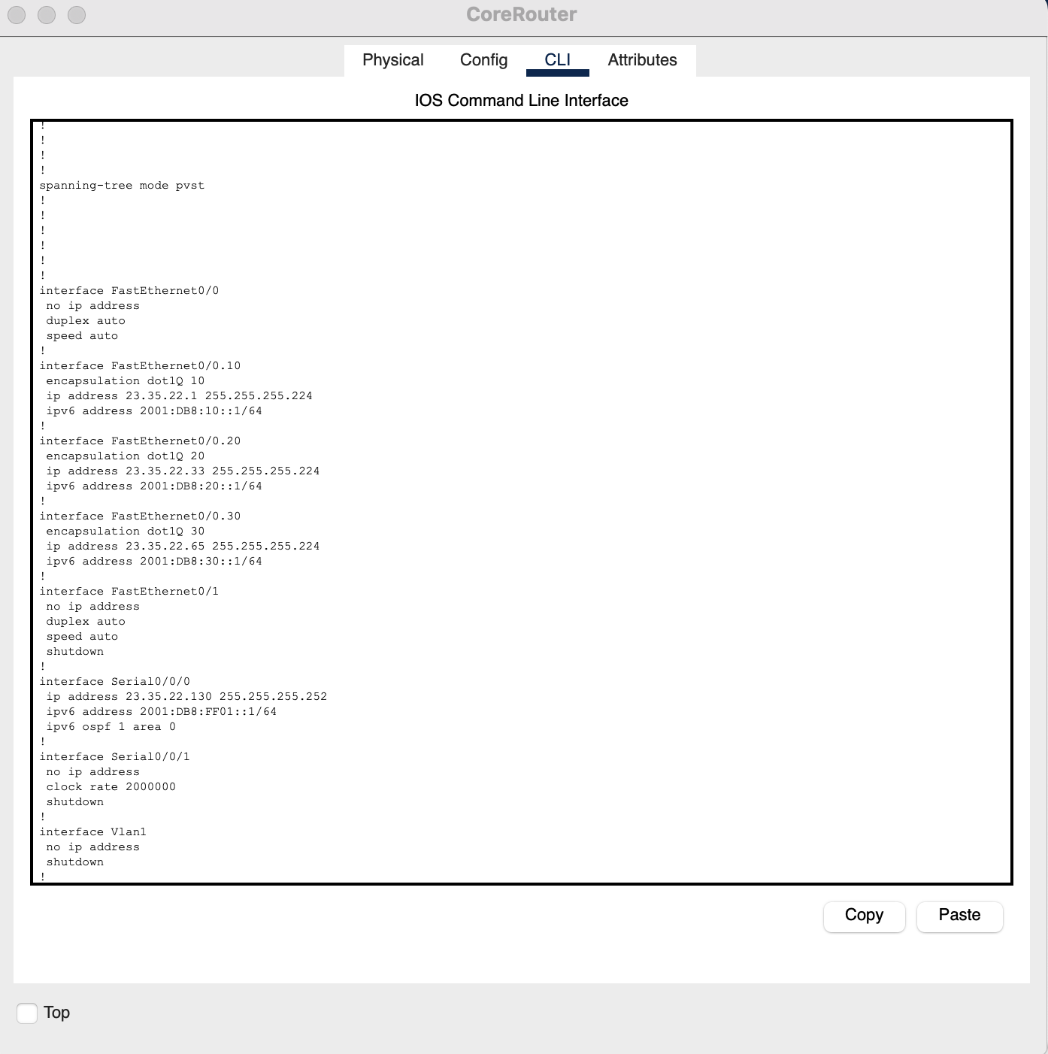
Figure 2: shows core router running configuration

Additional Technical Implementation Figures
IPv4 and IPv6 Dual-Stack Routing Implementation
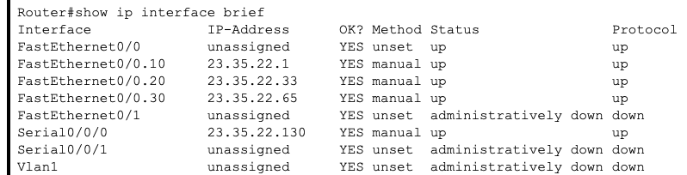
Figure 3: shows IPv4 interface brief
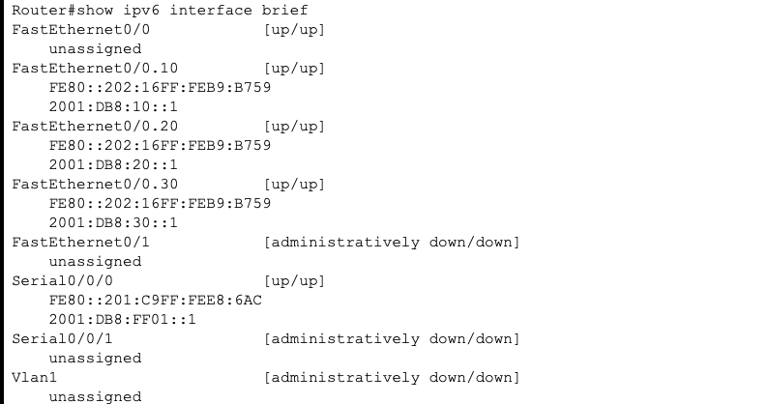
Figure 4:Interface of ipv6
Routing of Ipv4 and Ipv6:
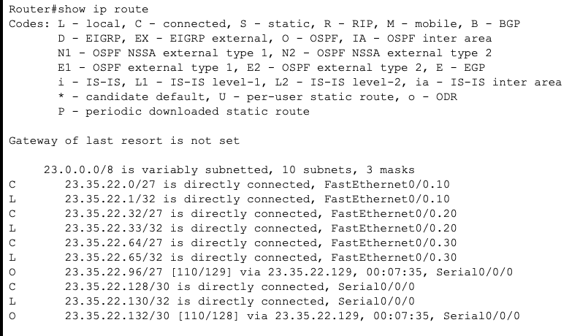
Figure 5 : Ipv4 routing table
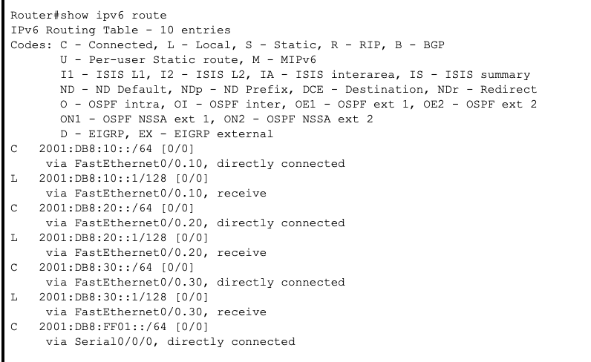
Figure 6 : IPv6 routing tableOSPf of router
Router Setup with DHCP and OSPF Implementation
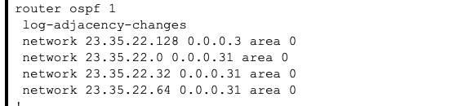
Figure 7: OSPF configuration of router
DHCP configuration of router
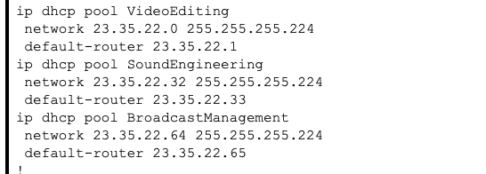
Figure 8: DHCP configuration of router
This set of configurations demonstrates the main router with DHCP pools, OSPF routing and routing between VLANs. An MIT value ID scheme (23.35.22.0/24) has been used with /27 subnets, each able to host 30 devices per VLAN. With OSPF, the network always updates routes and using DHCP means mobile devices get their IP address automatically.
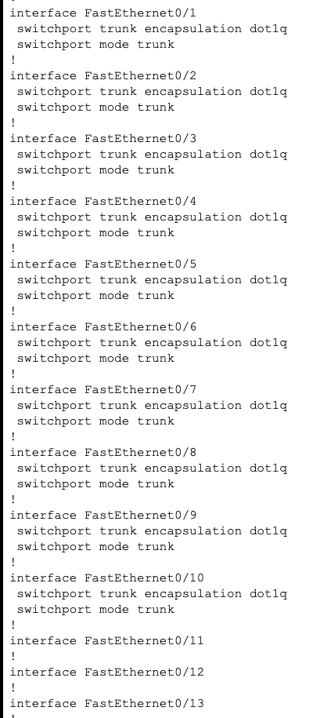
VLAN Configuration and Trunk Port Setup

Figure 9 : Running configuration of Multilayer switch
VLAN configuration:
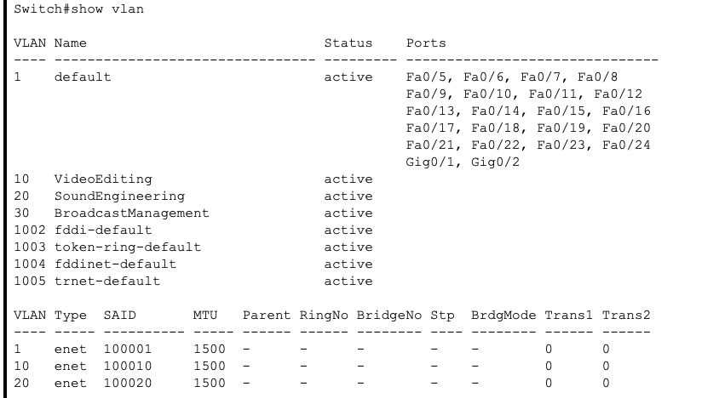
Figure 10: shows VLAN configuration of Multilayer switch :
Multilayer switches create different LANs and trunk ports are used for connecting switches to give security and improve their performance.

Access Layer Switch Port Configuration
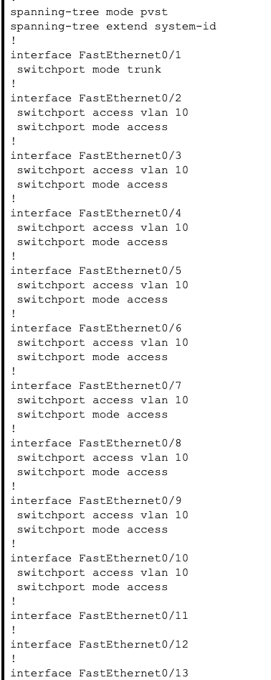
Figure 11 : Trunking configuration of access switch for vlan 10
Access switch VLAN configuration
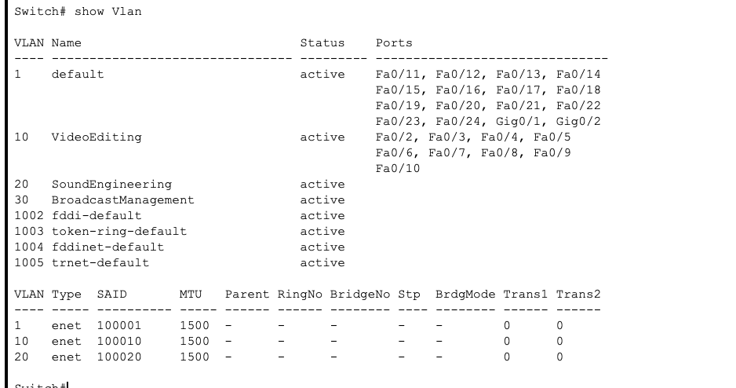
Figure 12 : access switch vlan configuration
With the access switch settings set appropriately, VLANs and port security are in place to correctly connect end devices where they belong.

DHCP Client Connectivity Verification
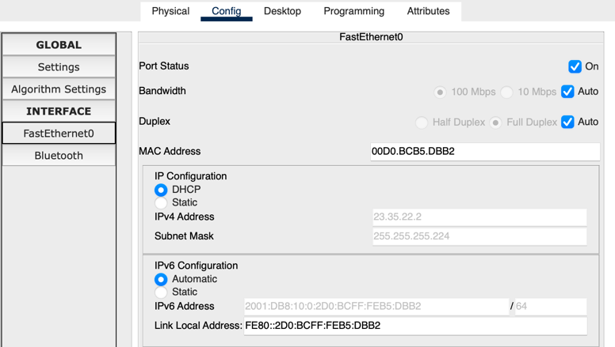
Figure 13 : DHCP allocation on Vlan 10
The images of the DHCP assignment show that IP addresses have been distributed automatically on every VLAN, confirming the network is ready for use anywhere.

Ping connectivity within VLAN
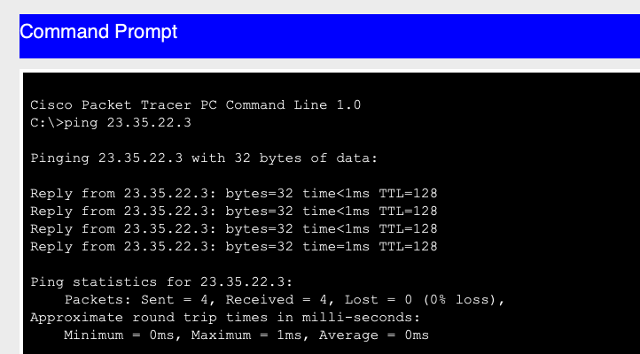
Figure 14: Ping test within network VLAN 10
Ping connectivity with other VLAN devices
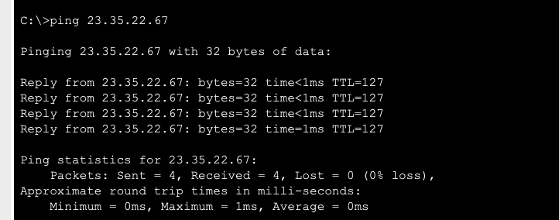
Figure 15: Ping test with other device on different vlan(30)

The results of the ping prove that all VLANs are properly separated on the network and that the core router permits communication between the broadcast departments.
The design adheres to industry guidelines and follows industry standards with three layers of architecture (core, distribution, and access layers) which provides segregation of network functions clearly along with scalability and redundancy. Physical stacking with high availability capabilities along with routing is used at the core layer through stacked Layer 3 switches (SG6428X). SG3452P and SG3560-24PS are the distribution layer switches that forward traffic to the core and provide connectivity between devices at the access layer [12]. The access layer contains SG3428MP and SG2960-24TT that provide end-user station connectivity and PoE where the devices are to be supported.

a. Gain Visibility and Control by End Users (Human Factor Considerations)
Human-focused design is highlighted in the following respects:
- Intuitive Network Management: Omada SDN controller provides a graphically based intuitive user interface that renders management simple enough for non-experts to understand, even for real-time network topology mapping to speed up troubleshooting [14].
- Role-Based Access Control: Administrative privileges are tailored to the responsibilities of the users so that audio engineers can manage audio network segments while video groups control video-related resources, reducing the learning curve for expert staff.
- Visual Alert System: The system employs prioritized alerts and color-coded notifications that allow the technicians to quickly identify critical issues in live broadcasts where time is critical [16].
- Mobile Accessibility: The Omada platform is accessible from mobile devices, enabling the technician to monitor the health of the networks as he moves around the OB van for setup and broadcast activities.
- Descriptive VLAN Names: VLANs are given descriptive names (e.g., "VLAN 10 - Video Editing" rather than with just numerical designations), which aids in recognizing network resources for employees [11].
- QoS Visualization: End users are able to view bandwidth allocation and prioritization settings via interface charts, which inform them why specific types of traffic get priority during heavy usage.
Human-centric design elements optimize workflow efficiency according to how broadcasters actually operate, reducing the cognitive load of high-stress live events.

b. Realize Strategic Solutions of Designed Network
Strategic use of next-generation network protocols will enhance network performance, reliability, and security as a whole:
- Border Gateway Protocol (BGP): Set up between the Internet Router and ISP connections (ASN 2811) to enable failover and load balancing for multiple ISP connections for seamless internet broadcasting.
- Open Shortest Path First (OSPF): Deployed as the interior routing protocol across the core network infrastructure to enable instant convergence and dynamic link state-driven routing choice. This provides significant redundancy for real-time broadcast traffic.
- Link Aggregation Control Protocol (LACP): Deployed between the core and distribution switches to create aggregated links that offer link-level redundancy and increased bandwidth. LACP with 802.3ad standard compliance is used to spread loads across physical links [13].
- Spanning Tree Protocol (RSTP/MSTP): Employed to prevent Layer 2 loops but maintain physically redundant paths, with Multiple Spanning Tree Protocol configured to maintain in accordance with VLAN topology for optimal path selection.
- Protocol Independent Multicast (PIM): Deployed on Broadcast Control Router for efficient multicast video stream management between the workstations to reduce network load in multi-viewer set-ups.
- Virtual Router Redundancy Protocol (VRRP): Implemented between the core routers to provide gateway redundancy to enable automatic failover for default gateway services.
They work together to present a highly stable network infrastructure that can withstand uninterrupted operation even in the event of component failure—a critical requirement for live broadcast applications.

c. Future Trends in Networking
The solution employs a series of emerging technologies in combination with the support for future expansion.
- Software-Defined Networking (SDN): Omada SDN controller delivers centralized policy management and programmable network control to allow instant policy adjustment to changing broadcast demands without physical re-configuration.
- Network Function Virtualisation (NFV): Virtual network functions may be deployed over the underlying hardware to encompass features like advanced security scans or customized media protocols without adding hardware.
- IPv6 Implementation: Although using IPv4 addressing at present, the network is completely IPv6-capable with dual-stack setup feasible on all devices to aid future IPv6 transition without requiring hardware replacement.
- Open Network Switches: Future upgrades within the network can be supported by the network design using open networking equipment for increased flexibility in the choice of network operating system and add-ons.
- AI-Based Network Analysis: The system lays the groundwork for future deployment of AI-based traffic analysis to facilitate predictive equipment maintenance, and automated quality of service optimizations based on observed media traffic patterns [15].
- 5G Integration: The network is designed to integrate seamlessly with the 5G private networking technology for wireless camera connectivity and remote contribution workflows in order to expand the capabilities of the production beyond the limitations of the physical OB van.
- Multi-Band Routers: Multi-band functionality can be integrated into the routing infrastructure to enable multiple ranges of frequencies for wireless connection to further remote operation capability.
By remaining ahead in this manner, the TV Skyline OB van network will remain viable and remain adaptable with the evolving technology trending further toward higher resolutions and more decentralized forms of broadcasting.

3. Innovative Ideas

a. Network Performance Improvement
The solution integrates SDN programme attributes with traditional routing (BGP/OSPF) to facilitate a fault-resilient hybrid architecture. A smart cascading QoS mechanism dynamically assigns traffic based on production phases (setup, rehearsal, live), assigning valuable bandwidth [12]. Media-aware optimisation recognises and optimises flows for particular types of media (video, audio, graphics). Cross-layer redundancy coordination prevents failovers from happening at the same time, ensuring maximum uptime. Dynamic reconfiguring of broadcast domains in real-time for the purpose of optimising traffic is also achieved. All of these breakthroughs are UHD mobile broadcasting demand-oriented, supporting robust, adaptive, high-performance performance.

b. Network Architecture Selection Rationale
A redesigned three-tier hierarchical design with stacked core switches provided the resiliency, efficiency, and capacity the customer was looking for. It has N+1 redundancy, minimizes cabling ideal for space-limited OB vans and is future-proof for 8K broadcasting [14]. The architecture also gives sub-millisecond latency and is industry standard-compliant for easier troubleshooting under pressure. It also satisfies the needs of high availability while being cost-effective, an ideal fit for TV Skyline's mobile production environment.

References
[1] M. Ulieru, "Design for Resilience of Networked Critical Infrastructures," in Proc. IEEE Int. Conf. Digital Ecosystems and Technologies, Feb. 2007, pp. 1-6.
[2] P. Karhunen, "Improving Information Security in Healthcare Networks With Software-Defined Networking," Bachelor's thesis, Haaga-Helia University of Applied Sciences, Helsinki, Finland, 2020.
[3] J. Marron, "Implementing the Health Insurance Portability and Accountability Act (HIPAA) Security Rule," NIST Special Publication 800-66 Rev. 2: Guide to Network Security for Healthcare Organizations, National Institute of Standards and Technology, Gaithersburg, MD, USA, 2024.
[4] A. M. Abdelrahman, J. J. Rodrigues, M. M. Mahmoud, K. Saleem, A. K. Das, V. Korotaev, and S. A. Kozlov, "Software‐defined networking security for private data center networks and clouds: vulnerabilities, attacks, countermeasures, and solutions," Int. J. Commun. Syst., vol. 34, no. 4, p. e4706, Mar. 2021.
[5] M. M. Billal, M. M. Hasan, M. A. Ahmed, and M. N. Hasan, "An Extensive Design and Implementation of a Campus Network Infrastructure Design," Ph.D. dissertation, Dept. Computer Science and Engineering, Soanargaon University, Dhaka, Bangladesh, 2023.
[6] N. S. Shaji and R. Muthalagu, "Survey on security aspects of distributed software-defined networking controllers in an enterprise SD-WLAN," Digital Communications and Networks, vol. 9, no. 4, pp. 891-904, Aug. 2023.
[7] S. K. Keshari, V. Kansal, and S. Kumar, "A systematic review of quality of services (QoS) in software defined networking (SDN)," Wireless Personal Communications, vol. 116, no. 3, pp. 2593-2614, Feb. 2021.
[8] M. Rahouti, K. Xiong, and J. Lin, "Leveraging a cloud‐based testbed and software‐defined networking for cybersecurity and networking education," Engineering Reports, vol. 3, no. 10, p. e12395, Oct. 2021.
[9] M. Hassan, M. A. Gregory, and S. Li, "Multi-domain federation utilizing software defined networking---a review," IEEE Access, vol. 11, pp. 19202-19227, Feb. 2023.
[10] A. A. Barakabitze and R. Walshe, "SDN and NFV for QoE-driven multimedia services delivery: The road towards 6G and beyond networks," Computer Networks, vol. 214, p. 109133, Sep. 2022.
[11] R. Kalan and I. Dulger, "A Survey on QoE Management Schemes for HTTP Adaptive Video Streaming: Challenges, Solutions, and Opportunities," IEEE Access, vol. 12, pp. 45123-45145, Mar. 2024.
[12] R. Viola, "Network-aware video streaming for future media Internet," Ph.D. dissertation, Dept. Electronics and Telecommunications, Universidad del País Vasco-Euskal Herriko Unibertsitatea, Bilbao, Spain, 2021.
[13] R. Viola, Á. Martín, M. Zorrilla, J. Montalbán, P. Angueira, and G. M. Muntean, "A survey on virtual network functions for media streaming: Solutions and future challenges," ACM Computing Surveys, vol. 55, no. 11, pp. 1–37, Nov. 2023.
[14] M. Rayani, "Architectures and Algorithms for Content Delivery in Future Networks," Ph.D. dissertation, Dept. Electrical and Computer Engineering, Concordia University, Montreal, QC, Canada, 2022.
[15] L. Peroni, "User Empowerment in Adaptive Video Streaming over Best-Effort Networks," Ph.D. dissertation, Dept. Telematics Engineering, Universidad Carlos III de Madrid, Madrid, Spain, 2025.
[16] D. Kafetzis, S. Vassilaras, G. Vardoulias, and I. Koutsopoulos, "Software-defined networking meets software-defined radio in mobile ad hoc networks: state of the art and future directions," IEEE Access, vol. 10, pp. 9989–10014, Jan. 2022.

